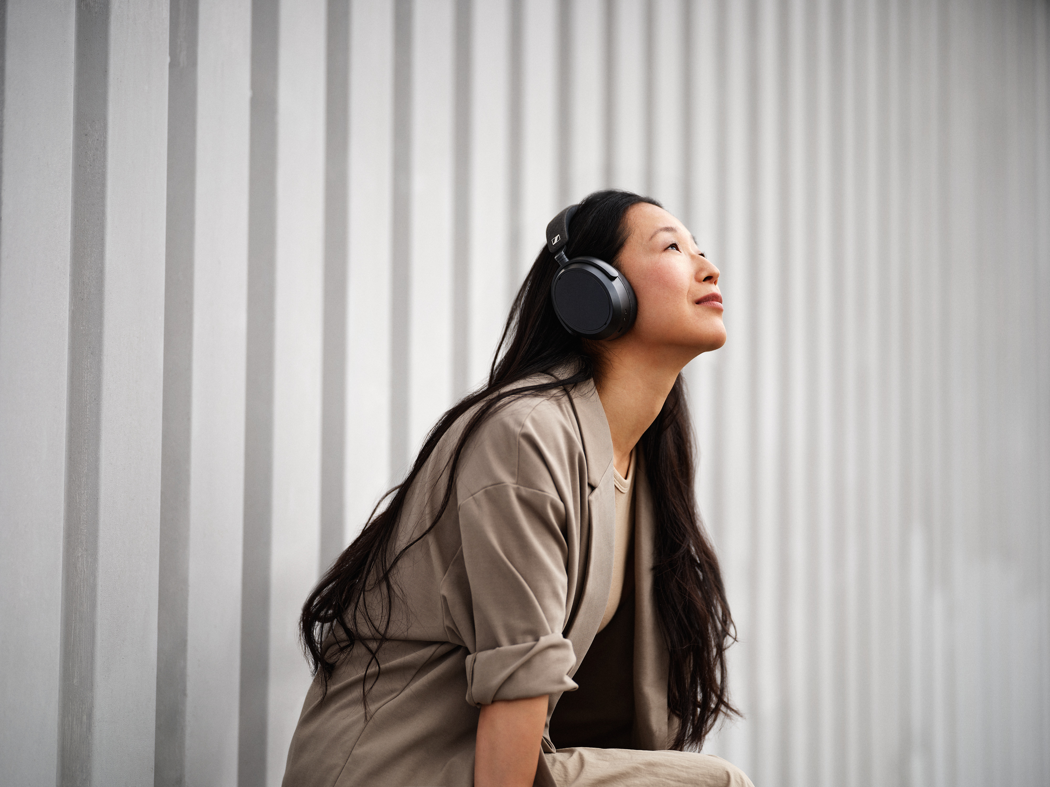
Under embargo until 12:00am (CEST), August 9, 2022
AUDIO EXCELLENCE AND COMFORT REDEFINED
The new Sennheiser MOMENTUM 4 Wireless – the perfect balance between superior sound and exceptional comfort
Wedemark, August 9, 2022 – Sennheiser’s MOMENTUM range continues to redefine the standard for sophisticated listening through superior sound. Now, the new MOMENTUM 4 Wireless raises the bar even higher, with best-in-class sound, advanced Adaptive Noise Cancellation and exceptional comfort. With smart, intuitive features that enhance every interaction and an outstanding battery life of up to 60 hours, there’s nothing between users and an incredible listening experience.

"Our MOMENTUM range has always set the standard for sophisticated listening with superior sound,” says Christian Ern, Sennheiser Principal Product Manager Consumer Headphones. “The new MOMENTUM 4 Wireless once again raises the bar – delivering best-in-class sound quality with advanced Adaptive Noise Cancellation and exceptional comfort. Thanks to features including Transparency Mode, Built-in EQ and a new Sound Personalization feature, users can listen in their own customized way."
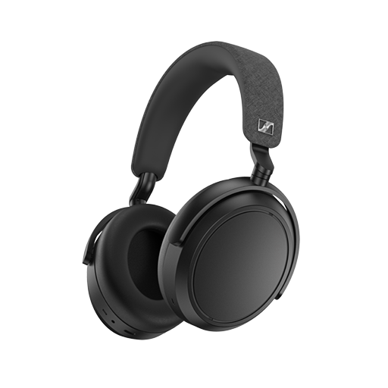
Experience superior sound, hear every detail
MOMENTUM 4 Wireless delivers Sennheiser’s Signature Sound that surpasses everything in its class – letting users enjoy their music as never before. Thanks to an audiophile-inspired acoustic system powered by a 42mm transducer, the MOMENTUM 4 Wireless provides brilliant dynamics, clarity and musicality. Its next generation Adaptive Noise Cancellation ensures users stay immersed, hearing every thrilling detail even in noisy environments.

Alternatively, when users need to talk to others or hear surrounding sounds without removing their MOMENTUM 4 Wireless, the versatile Transparency Mode lets them hear outside sounds through the headphones at a touch. And for a truly tailored experience, the Sennheiser Smart Control app makes it easy to customize the sound using the Built-in EQ, sound modes and the new Sound Personalization feature. This assesses the user’s listening preferences and adjusts the listening experience according to their taste.

With the MOMENTUM 4 Wireless every interaction is effortless. Calls and voice assistant interaction is incredibly natural and disturbance-free thanks to an advanced 2x2 digital beamforming microphone array and automatic wind noise suppression, which guarantees superior voice pick-up.

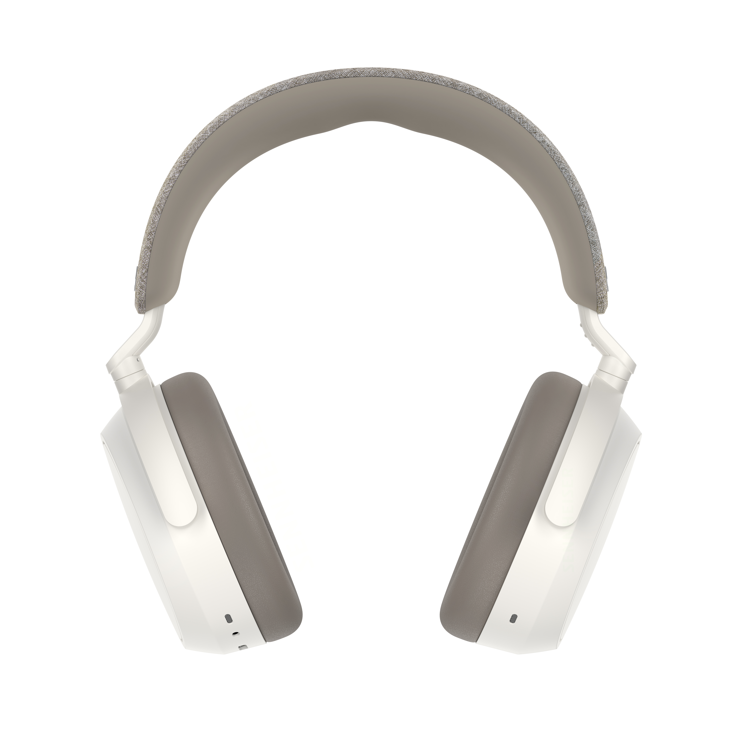
Enjoy exceptional comfort
The MOMENTUM 4 Wireless defines elegance with an all-new design that perfectly balances exceptional comfort and streamlined style. For all-day use without fatigue, it combines lightweight with a richly padded headband and deep cushioned earpads. Meanwhile, the low-friction hinge mechanism easily adjusts to guarantee a great fit without placing excess pressure on the user’s head. The fold-flat design is also comfortable when worn around the neck and can be easily slipped into a bag or backpack in the slim case when on the go.

An effortlessly smart user experience
With an outstanding battery life of up to 60 hours and fast charging capability that can provide a further six hours listening in just 10 minutes, MOMENTUM 4 Wireless keeps the entertainment coming for long listening sessions and long-haul travel alike. Every interaction is effortless, and every need anticipated: Smart Pause halts playback when the headphones are taken off and resumes when placed back on the ears, so users never miss a beat, while Auto On/Off rapidly powers up the headset when it’s picked up and shuts down to save energy when not in use.

The touchpad interface of the MOMENTUM 4 Wireless, combined with voice and sound prompts, make controlling music, calls and voice assistants intuitive and easy to navigate. Set up is also simple thanks to Bluetooth device management that allows multiple devices to be connected at the same time.

Pricing and availability
The Sennheiser MOMENTUM 4 Wireless will be available for pre-order globally on August 9, 2022, and for sale from August 23, with an MSRP of 349.90 Euros.

About the Sennheiser brand
We live and breathe audio. We are driven by the passion to create audio solutions that make a difference. Building the future of audio and bringing remarkable sound experiences to our customers – this is what the Sennheiser brand has represented for more than 75 years. While professional audio solutions such as microphones, meeting solutions, streaming technologies and monitoring systems are part of the business of Sennheiser electronic GmbH & Co. KG, the business with consumer devices such as headphones, soundbars and speech-enhanced hearables is operated by Sonova Holding AG under the license of Sennheiser.
www.sennheiser.com
www.sennheiser-hearing.com

Press contact
Sonova Consumer Hearing GmbH
Paul Hughes
Head of PR and Influencers
Sennheiser Headphones & Soundbars
T +49 (0) 162 2921 861
paul.hughes@sennheiser-ce.com

